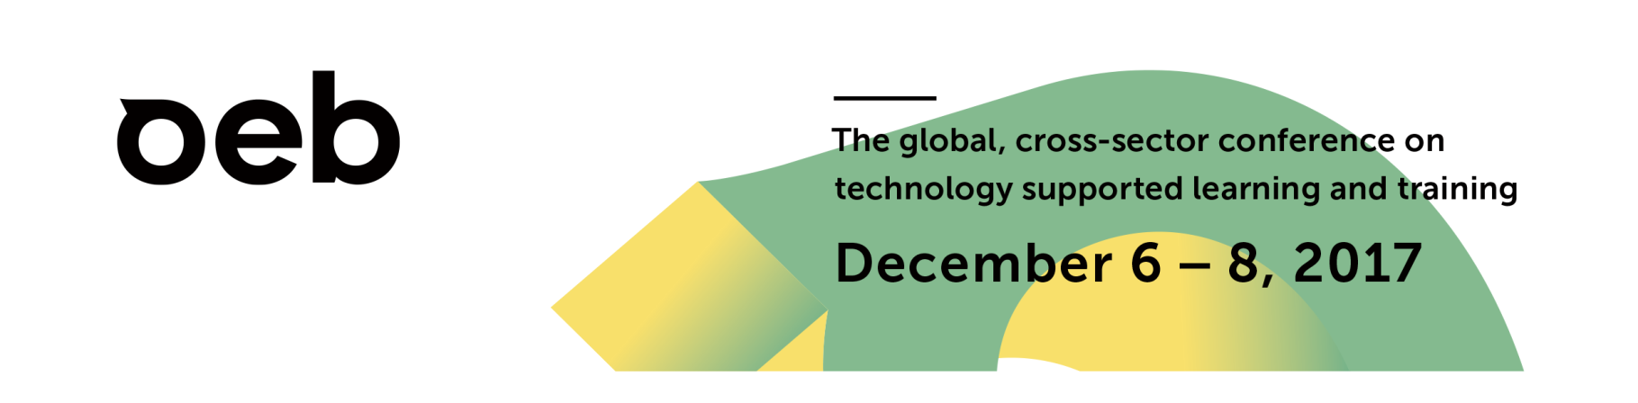

Plenary Title OEB Opening Plenary: Learning Uncertainty
Date and Time Thursday, Dec 7, 09:30 – 11:00
Location Room Potsdam I/III

Plenary Outline Uncertainty is the defining characteristic of our age. Are workplaces, governments and societies prepared for our uncertain future? How should universities, colleges, schools and workplaces adapt? What should employers do now to plan for the flexible workforce they will need in the future? OEB's Opening Plenary session is about acknowledging uncertainty and preparing for it. It shows how transformative education, training and learning can equip businesses, organisations and individuals with the skills to survive and prosper.

Format The aim of the Plenary is to create interaction and the atmosphere of a giant conversation, to set the overall tone for the conference. From the get-go the audience will be encouraged by the moderator to be part and explore the themes and elements the 3 speakers raise in their talks via social media. This audience feedback will drive the direction of travel for the session after each talk and during the final part of the session. The proposed timings are: Nik 5 min (welcome and introductions), Aleks 15 min (on “The Tales, They Are a’Changing), Abigail 15 min (on “Clash of revolutions”), Pasi 15 min (on “Myths and Facts about the Future of Schooling”), Q&A with your audience 40 min.

Audience Every year, OEB Global attracts over 2,300 participants from more than 90 countries worldwide, making it the most comprehensive annual meeting place for technology-supported learning and training professionals from the corporate, education and public service sectors. Participants include e-learning directors, chief learning officers, corporate training managers, senior staff from government departments and deans, directors and researchers from the higher education sector to name but a few. Leading suppliers and providers also take part, exhibiting in an extensive area for social and professional networking, and a number of networking events are held at and around the exhibition stands.

Links Detailed information about the make-up of the inter-sectoral and international audience can be found here.
Information about our overall 2017 theme, Learning Uncertainty, can be found in the quick facts sheet here.
A PDF of the conference agenda can be found here.

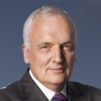 | Nik Gowing  Broadcast Journalist and Session Moderator  Nik Gowing was a main news presenter for the BBC’s international 24-hour news channel BBC World News 1996-2014. He presented The Hub with Nik Gowing, BBC World Debates, Dateline London , plus location coverage of major global stories. In 2016 Nik Gowing co-authored interim findings of the “Thinking the Unthinkable” study. The work is currently scaling up because of global anxieties about the new pressures on leaderships. It is based on hundreds of top level confidential interviews and conversations with corporate and public service leaders, plus hundreds more conversations with the new generation of millennials.

Aleks Krotoski
Social Psychologist and Broadcaster at the Guardian, UK

Dr Aleks Krotoski is an award-winning international broadcaster, author and academic, having worked for the BBC and Channel 4, writing and presenting the landmark technology and social-science series for both radio and international television, and for The Guardian, with the Tech Weekly podcast (2007-2015), The Biggest Story In The World (2015), and has taken her hit weekly column from newspaper to acclaimed book (Guardian Faber, 2013). Her award-winning video series for The Guardian, “The Power of Privacy”, was produced in 2015 in 5 countries and her BBC Radio 4 series Codes That Changed The World is the most requested radio series on BBC iPlayer.

Abigail Trafford
Author and Leader in the Movement to Fight Ageism, USA

Abigail Trafford, an award-winning journalist and bestselling author, focusses on longevity and the impact of longer—healthier—lives on society and politics. A former columnist and health editor at The Washington Post, she was a journalism fellow at the Harvard School of Public Health and the International Longevity Center in New York, and a visiting scholar at the Center on Longevity at Stanford University. The author of Crazy Time, My Time and As Time Goes By, she lives in Boston, MA.

Pasi Sahlberg
Educator, Author and Changemaker, Finland

Pasi has worked as schoolteacher, teacher educator, researcher, and policy advisor in Finland and has studied education systems and reforms around the world. His book Finnish Lessons 2.0: What Can the World Learn from Educational Change in Finland won the 2013 Grawemeyer Award for an idea that has potential to change the world. He is also a recipient of the 2012 Education Award in Finland, the 2014 Robert Owen Award in Scotland, the 2016 Lego Prize, and Rockefeller Foundation Bellagio Resident Fellowship in 2017. He is a former director general at the Finland’s Ministry of Education and a visiting Professor of Practice at Harvard University’s Graduate School of Education.

Plenary Title Getting Ready for More Agency

Date and Time Friday, Dec 8, 09:30 – 11:00

Location Room Potsdam 1

Plenary Outline “Business, education and society all need to be ready for action in a new world. And being ready for action means being ready to adapt – quickly, fundamentally and often. How should a school, an institution or a learner change to keep pace with new technologies and economic turbulence? How will schools, colleges and universities redefine their “service delivery” for tomorrow’s “consumers” or “customers” of education? Are schools, colleges and universities agile enough? Is the flexibility of education more relevant to the needs of the future than the discipline of training? Are today’s education systems flexible enough? Do current policies offer adequate guidelines to implement change? Are today’s virtual platforms, physical establishments and educators ready to adapt for the demands of tomorrow? Join this panel for different views on how learning can and must change”

Format The aim of this Plenary which will include 3 keynote presentations of about 25 min in length is to help set the tone for the second day of the conference. We hope it will motivate, educate and engage all our participants coming from different sectors and countries. Suggested timings are: Ada Pellert, offering welcoming remarks (5 min), Lauren Herckis, presenting The Paces of Change (25 min), Sanjay Sarma presenting The New Age of Learning (25 minutes), Andrew Keen, presenting How to Fix the Future (25 minutes), Ada Pellert, offering closing remarks (5 minutes).

Audience Every year, OEB Global attracts over 2,300 participants from more than 90 countries worldwide, making it the most comprehensive annual meeting place for technology-supported learning and training professionals from the corporate, education and public service sectors. Participants include e-learning directors, chief learning officers, corporate training managers, senior staff from government departments and deans, directors and researchers from the higher education sector to name but a few. Leading suppliers and providers also take part, exhibiting in an extensive area for social and professional networking, and a number of networking events are held at and around the exhibition stands.

Detailed information about the make-up of the inter-sectoral and international audience can be found here.
Information about our overall 2017 theme, Learning Uncertainty, can be found in the quick facts sheet here.
A PDF of the conference agenda can be found here.

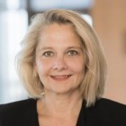 | Ada Pellert  Rector of the FernUniversität in Hagen, Chairperson of the Plenary  Prof. Dr. Ada Pellert, economist, has been the Rector of the University of Hagen since March 2016. With about 76,000 students, it is the only state-maintained distance teaching university in the German-speaking countries and regions, offering a real alternative to on-campus studies with high-quality final degrees (Bachelor, Master and Doctorate) and a focus to support lifelong learning.  Ada Pellert has held a variety of positions, including management roles, in the distance and e-learning landscape. She is currently serving as chairperson of the board of a collaborative initiative on Digitisation of 41 HE institutions in Germany, the DH-NRW.

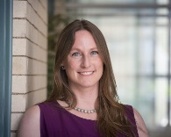 | Lauren Herckis  Anthropologist Specialising in Faculty Culture and the Use of Technology at Carnegie Mellon University, USA  Lauren Herckis is an anthropologist at Carnegie Mellon University with appointments in the Dietrich College of Humanities and Social Sciences and the Human-Computer Interaction Institute in the School of Computer science. Her research in Latin America interrogates assumptions about cultural heterogeneity in the context of long-term urban growth, and highlights the ways that social networks dynamically impact technical choices and the development of informal economies. Under the aegis of Carnegie Mellon's Simon Initiative, Dr. Herckis' current projects explore the intersection of campus culture, technological change, and effective teaching at the college level. Her research informs policymaking, shapes the development of learning technologies, and illuminates aspects of organizational culture and policy which affect teaching practice
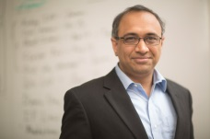 | Sanjay Sarma  Vice President for Open Learning at Massachusetts Institute of Technology, USA  Sanjay Sarma is a Professor of Mechanical Engineering at MIT and Vice President for Open Learning at the Institute. He overseas OpenCourseWare, MITx, MicroMasters, the new MIT Integrated Learning Initiative and the World Education Lab at MIT. As a researcher, he founded the Auto-ID Center at MIT and developed many of the key technologies behind the EPC suite of RFID standards now used worldwide. He was also the the founder and CTO of OATSystems, which was acquired by Checkpoint Systems (NYSE: CKP) in 2008. His current research interests are Internet of Things, street scanning, sensing, RFID, logistics and manufacturing.

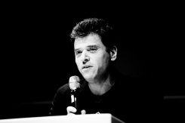 | Andrew Keen  Author, Entrepreneur and Controversial Commentator on the Digital Revolution, USA  Andrew Keen is one of the world’s best known and controversial commentators on the digital revolution. He is the author of three books: Cult of the Amateur, Digital Vertigo and his current international hit The Internet Is Not The Answer which the London Sunday Times acclaimed as a "powerful, frightening read" and the Washington Post called "an enormously useful primer for those of us concerned that online life isn't as shiny as our digital avatars would like us to believe". He is executive director of the Silicon Valley innovation salonFutureCast and a much acclaimed public speaker around the world. In 2015, he was named by GQ magazine in their list of the "100 Most Connected Men”. His next book, How To Fix The Future, will be published worldwide in January 2018.

Plenary Title Workplace Learning Starts Here

Date and Time Friday, Dec 8, 09:30 – 11:00

Location Room Potsdam 3

Plenary Outline How can organisations align training, learning and development with business goals? How can higher education and the TVET sector interact more effectively with the workplace? How can workplaces remain human-centered and use new technologies to keep the momentum to implement continuous change? What are the best ways to encourage dynamic cooperation? Join us for talks and a lively discussion on making workplace learning fit for the future.

Format The aim of the Plenary is to create interaction and the atmosphere of a giant conversation, to set the overall tone for the day. From the get-go the audience will be encouraged by the moderator, to be part and explore the themes and elements the 3 speakers raise in their talks via social media. This audience feedback will drive the direction of travel for the session after each talk. The timings are: Nik, 5 min, Alan 15 min, Patrick 15 min, Heather 15 min, Q&A with your Audience 40 min.

Audience The Plenary addresses the audience attending OEB’s Business EDUCA track, one of the pillars of the conference, dedicated to the needs of CLOs, HR professionals and learning & talent development leaders. This track aims to offer them a toolkit of skills, opportunities to exchange best practice with peers and insights on the latest trends and strategies that drive technology supported learning at work. Companies like Lidl, Isbank, BMW, Citi, Bayer, Merck and many more will be taking part.

For further information about the audience please view the details here.
Please find all Business EDUCA sessions on the agenda here.
Information about our overall 2017 theme, Learning Uncertainty, can be found in the quick facts sheet here.
A PDF of the conference agenda can be found here.

Nik Gowing
Broadcast Journalist and Session Moderator

Nik Gowing was a main news presenter for the BBC’s international 24-hour news channel BBC World News 1996-2014. He presented The Hub with Nik Gowing, BBC World Debates, Dateline London , plus location coverage of major global stories. In 2016 Nik Gowing co-authored interim findings of the “Thinking the Unthinkable” study. The work is currently scaling up because of global anxieties about the new pressures on leaderships. It is based on hundreds of top level confidential interviews and conversations with corporate and public service leaders, plus hundreds more conversations with the new generation of millennials.

Heather McGowan
Internationally Recognized Expert on the Future of Work and the Future of Learning, USA

Heather McGowan advises education and business leaders to most effectively prepare for rapid and disruptive changes in learning, work, and society. In higher education, McGowan advises presidents and senior leaders to develop students’ agile learning mindset in order to prepare graduates for jobs that do not yet exist.
Her corporate clients range from start-ups like publicly traded, Fortune 500 companies, including Autodesk and BD Medical. She is the co-author of the book Disrupt Together: How Teams Consistently Innovate (Pearson) and is writing a book on the future of work due out in 2018.

Find her recent article, the Learning Uncertainty Imperative, on OEB Insights here.

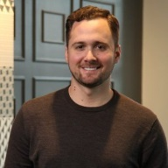 | Patrick King  Insights Lead, Learning Solutions at LinkedIn, USA  I have held a wide range of data-oriented roles in tech, media and finance. Most of this work has been focused on building data products for non-technical users (external and internal). Currently, I lead our insights team for Learning Solutions at LinkedIn, working across sales, marketing, engineering, product and analytics to understand how we can use LinkedIn's unique dataset to provide value to our customers in the e-learning space. In this role and my past, I have used a variety of technical tools including: distributed file systems (Hadoop), Relational Databases (SQL), Python, unix/bash, web development and whatever else was needed to get the job done.
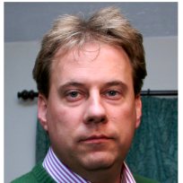 | Alan Ryan,  Director of National Programmes (HEE)  HEE’s Director of National Programmes is responsible for the delivery of a range of national programmes focusing on the education and training of the healthcare workforce in England, including Technology Enhanced Learning and e-Learning for Healthcare.  Alan is a trained nurse who practiced clinically for 18 years. Previous to this current role he has worked in senior management positions for the Department of Health including Project Director for the R-ITI programme, the award-winning e-learning project for radiology and HEE Technology Enhanced Learning Lead & National Programme Director for the e-Learning for Healthcare programme which drives high quality patient care by working in partnership with the NHS and UK professional bodies to develop nationally quality assured, curriculum based e-learning to support healthcare training across the UK. Other national roles include working with Modernising Medical Careers and the National Clinical Governance Support Team. Alan has been instrumental in driving e-learning and technology enhanced learning in the UK health sector.  Alan has a passion for using technology positively and his interest in education extends to Uganda where the Kiddies Support Scheme charity, for which he is a trustee, helps disadvantaged children escape poverty through education.

